 **NAME:** Yogesh S G

**EMAIL ID:** yogeshpoco17@gmail.com

Packet Tracer - Build a Switch and Router Network - Physical Mode

# Topology



**Addressing Table**

|  |  |  |  |
| --- | --- | --- | --- |
| **Device** | **Interface** | **IP Address / Prefix** | **Default Gateway** |
| R1 | G0/0/0 | 192.168.0.1 /24 | N/A |
|  |  | 2001:db8:acad::1/64 |  |
|  |  | fe80::1 |  |
|  | G0/0/1 | 192.168.1.1 /24 | N/A |
|  |  | 2001:db8:acad:1::1/64 |  |
|  |  | fe80::1 |  |
| S1 | VLAN 1 | 192.168.1.2 /24 | 192.168.1.1 |
| PC-A | NIC | 192.168.1.3 /24 | 192.168.1.1 |
|  |  | 2001:db8:acad:1::3/64 | fe80::1 |
| PC-B | NIC | 192.168.0.3 /24 | 192.168.0.1 |
|  |  | 2001:db8:acad::3/64 | fe80::1 |

# Objectives

#### Part 1: Set Up the Topology

**Part 2: Configure Devices and Verify Connectivity Part 3: Display Device Information**

# Background / Scenario

This is a comprehensive activity to review the IOS commands you have learned. In this Packet Tracer Physical Mode (PTPM) activity, you will cable the equipment as shown in the topology diagram. You will then configure the devices to match the addressing table. After the configurations have been saved, you will verify your configurations by testing for network connectivity.

After the devices have been configured and network connectivity has been verified, you will use IOS commands to retrieve information from the devices to answer questions about your network equipment.

This activity provides minimal assistance with the commands necessary to configure the router. Test your knowledge by trying to configure the devices without referring to the course content or the previous activities.

# Instructions

## Part 1: Set Up the Topology

1. Move the required router and switch from the **Shelf** to the **Rack**.
2. Move the required PCs from the **Shelf** to the **Table**.
3. Cable the devices, as shown in the **Topology** and the **Addressing Table**.

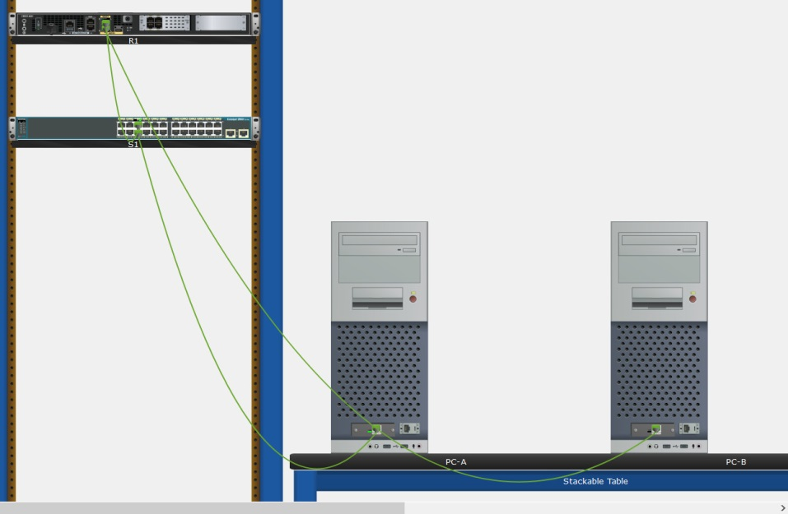

1. Power on all the devices.

## Part 2: Configure Devices and Verify Connectivity

In this part, you will set up the network topology and configure basic settings, such as the interface IP addresses, device access, and passwords. Refer to the **Topology** and **Addressing Table** at the beginning of this activity for device names and address information.

### Step 1: Assign static IP information to the PC interfaces.

1. On PC-A, configure the IP address, subnet mask, and default gateway settings.

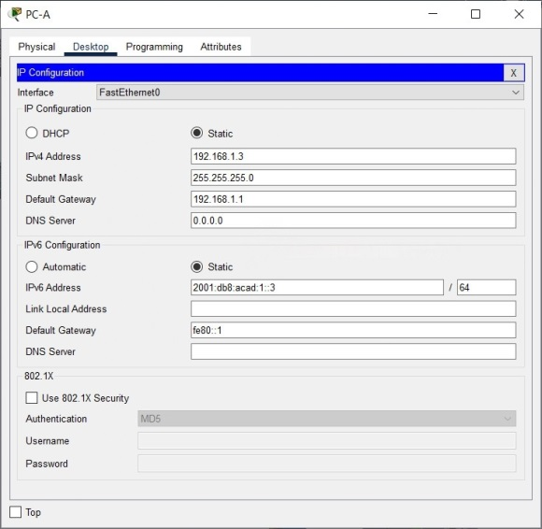

1. On PC-B, configure the IP address, subnet mask, and default gateway settings.

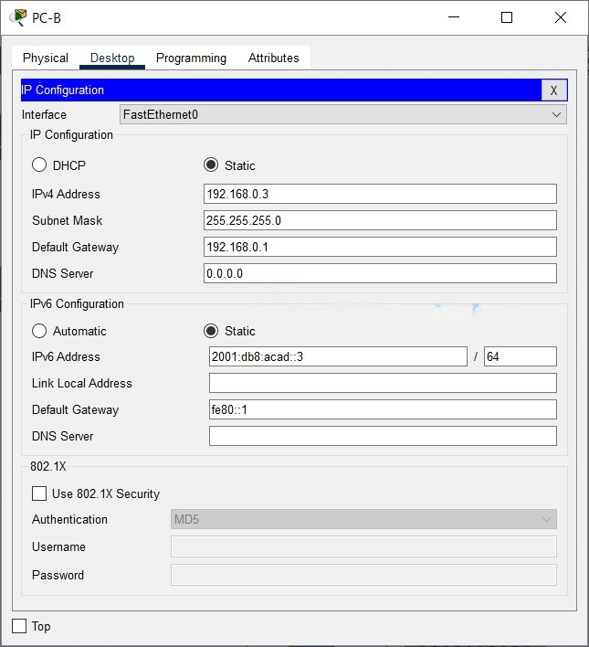

1. From a command prompt window on PC-A, ping PC-B.

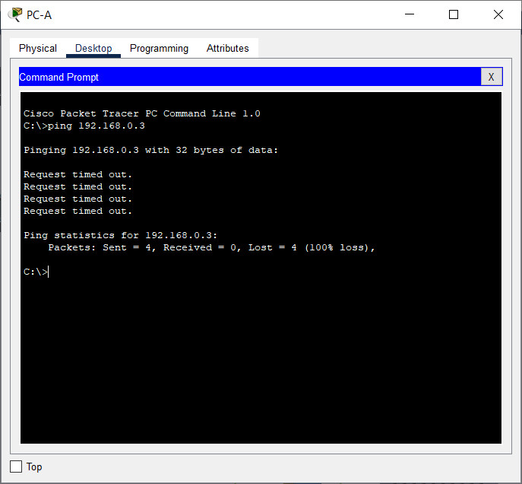

1. Why were the pings not successful? The router interfaces (default gateways) have not been configured yet so Layer 3 traffic is not being routed between subnets.

### Step 2: Configure the router.

1. Console into the router and enable privileged EXEC mode.

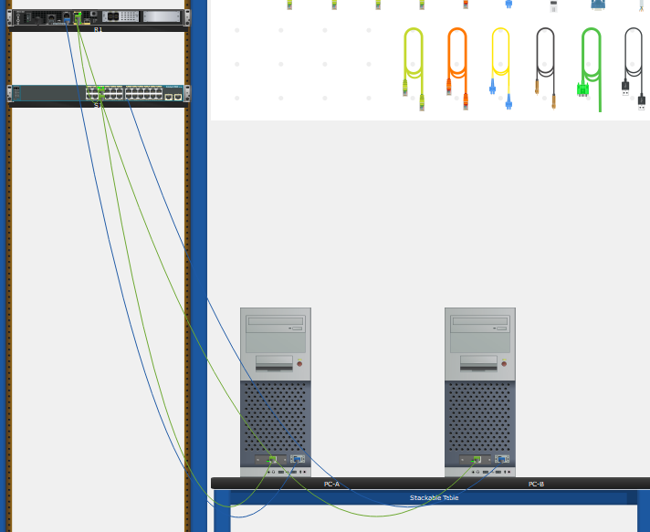

Router> **enable**

1. Enter configuration mode.

Router# **config terminal**

1. Assign the device name to the router.

Router(config)# **hostname R1**

1. Assign **class** as the privileged EXEC encrypted password.

R1(config)# **enable secret class**

1. Assign **cisco** as the console password and enable login.

R1(config)# **line console 0**

R1(config-line)# **password cisco**

R1(config-line)# **login**

1. Assign **cisco** as the vty password and enable login.

R1(config)# **line vty 0 4**

R1(config-line)# **password cisco**

R1(config-line)# **login**

1. Encrypt the plaintext passwords.

R1(config)# **service password-encryption**

1. Create a banner that warns anyone accessing the device that unauthorized access is prohibited.

R1(config)# **banner motd $ Authorized Users Only! $**

1. Configure and activate both interfaces on the router.

R1(config)# **interface g0/0/0**

R1(config-if)# **ip address 192.168.0.1 255.255.255.0**

R1(config-if)# **ipv6 address 2001:db8:acad::1/64**

R1(config-if)# **ipv6 address FE80::1 link-local**

R1(config-if)# **no shutdown**

R1(config-if)# **exit**

R1(config)# **interface g0/0/1**

R1(config-if)# **ip address 192.168.1.1 255.255.255.0**

R1(config-if)# **ipv6 address 2001:db8:acad:1::1/64**

R1(config-if)# **ipv6 address fe80::1 link-local**

R1(config-if)# **no shutdown**

R1(config-if)# **exit**

1. Configure an interface description for each interface indicating which device is connected to it.

R1(config)# **interface g0/0/1**

R1(config-if)# **description Connected to F0/5 on S1**

R1(config-if)# **exit**

R1(config)# **interface g0/0/0**

R1(config-if)# **description Connected to Host PC-B**

R1(config-if)# **exit**

1. To enable IPv6 routing, enter the **ipv6 unicast-routing** command.

R1(config)# **ipv6 unicast-routing**

1. Save the running configuration to the startup configuration file.

R1(config)# **exit**

R1# **copy running-config startup-config**

1. Set the clock on the router.

R1# **clock set 15:30:00 27 Aug 2019**

**Note**: Use the question mark (**?**) to help with the correct sequence of parameters needed to execute this command.

1. From a command prompt window on PC-A, ping PC-B.

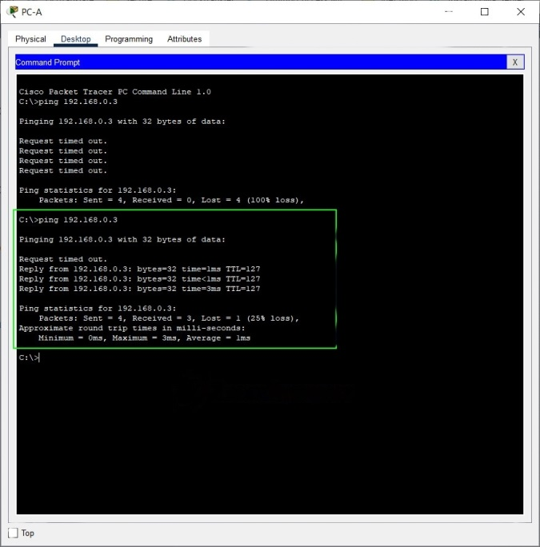

**Note**: If pings are not successful, the Windows Firewall may need to be turned off.

Were the pings successful? Explain.

Yes. The router is routing the ping traffic across the two subnets. The default settings for the 2960 switch will automatically turn up the interfaces that are connected to devices.

### Step 3: Configure the switch.

In this step, you will configure the hostname, the VLAN 1 interface, and its default gateway.

1. Console into the switch and enable privileged EXEC mode.

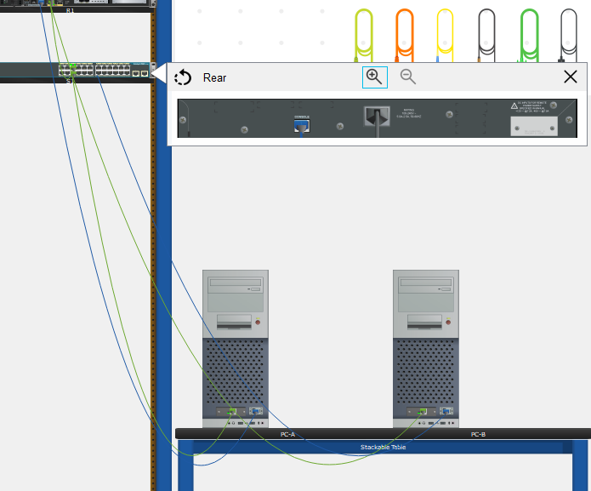

Switch> **enable**

1. Enter configuration mode.

Switch# **config terminal**

1. Assign a device name to the switch.

Switch(config)# **hostname S1**

1. Configure and activate the VLAN interface on the switch S1.

S1(config)# **interface vlan 1**

S1(config-if)# **ip address 192.168.1.2 255.255.255.0**

S1(config-if)# **no shutdown**

S1(config-if)# **exit**

1. Configure the default gateway for the switch S1.

S1(config)# **ip default-gateway 192.168.1.1**

S1(config-if)# **end**

1. Save the running configuration to the startup configuration file.

S1# **copy running-config startup-config**

### Step 4: Verify connectivity end-to-end connectivity.

1. From PC-A, ping PC-B.
2. From S1, ping PC-B.

All the pings should be successful.

## Part 3: Display Device Information

In Part 3, you will use **show** commands to retrieve interface and routing information from the router and switch.

### Step 1: Display the routing table on the router.

1. Use the **show ip route** command on R1 to answer the following questions.

R1# **show ip route**

Codes: L - local, C - connected, S - static, R - RIP, M - mobile, B - BGP

D - EIGRP, EX - EIGRP external, O - OSPF, IA - OSPF inter area

N1 - OSPF NSSA external type 1, N2 - OSPF NSSA external type 2

E1 - OSPF external type 1, E2 - OSPF external type 2

i - IS-IS, su - IS-IS summary, L1 - IS-IS level-1, L2 - IS-IS level-2

ia - IS-IS inter area, * - candidate default, U - per-user static route

o - ODR, P - periodic downloaded static route, H - NHRP, l - LISP

+ - replicated route, % - next hop override

Gateway of last resort is not set

192.168.0.0/24 is variably subnetted, 2 subnets, 2 masks

C 192.168.0.0/24 is directly connected, GigabitEthernet0/0/0

L 192.168.0.1/32 is directly connected, GigabitEthernet0/0/0

192.168.1.0/24 is variably subnetted, 2 subnets, 2 masks

C 192.168.1.0/24 is directly connected, GigabitEthernet0/0/1

L 192.168.1.1/32 is directly connected, GigabitEthernet0/0/1

What code is used in the routing table to indicate a directly connected network?

The C designates a directly connected subnet. An L designates a local interface. Both answers are correct.

How many route entries are coded with a C code in the routing table?

2

What interface types are associated to the C coded routes?

Answers may vary depending of router type, but on the 4221 the correct answer is G0/0/0 and G0/0/1.

1. Use the **show ipv6 route** command on R1 to display the IPv6 routes.

R1# **show ipv6 route**

IPv6 Routing Table - default - 5 entries

Codes: C - Connected, L - Local, S - Static, U - Per-user Static route

B - BGP, R - RIP, H - NHRP, I1 - ISIS L1

I2 - ISIS L2, IA - ISIS interarea, IS - ISIS summary, D - EIGRP

EX - EIGRP external, ND - ND Default, NDp - ND Prefix, DCE - Destination

NDr - Redirect, RL - RPL, O - OSPF Intra, OI - OSPF Inter

OE1 - OSPF ext 1, OE2 - OSPF ext 2, ON1 - OSPF NSSA ext 1

ON2 - OSPF NSSA ext 2, la - LISP alt, lr - LISP site-registrations

ld - LISP dyn-eid, lA - LISP away, le - LISP extranet-policy

a - Application

C 2001:DB8:ACAD::/64 [0/0]

via GigabitEthernet0/0/0, directly connected

L 2001:DB8:ACAD::1/128 [0/0]

via GigabitEthernet0/0/0, receive

C 2001:DB8:ACAD:1::/64 [0/0]

via GigabitEthernet0/0/1, directly connected

L 2001:DB8:ACAD:1::1/128 [0/0]

via GigabitEthernet0/0/1, receive

L FF00::/8 [0/0]

via Null0, receive

### Step 2: Display interface information on R1.

1. Use the **show interface g0/0/1** to answer the following questions.

R1# **show ip interfaces g0/0/1**

GigabitEthernet0/0/1 is up, line protocol is up

Hardware is ISR4321-2x1GE, address is a0e0.af0d.e141 (bia a0e0.af0d.e141)

Description: Connectd to F0/5 on S1

Internet address is 192.168.1.1/24

MTU 1500 bytes, BW 100000 Kbit/sec, DLY 100 usec,

reliability 255/255, txload 1/255, rxload 1/255

Encapsulation ARPA, loopback not set

Keepalive not supported

Full Duplex, 100Mbps, link type is auto, media type is RJ45

output flow-control is off, input flow-control is off

ARP type: ARPA, ARP Timeout 04:00:00

Last input 00:00:00, output 00:00:19, output hang never

Last clearing of "show interface" counters never

Input queue: 0/375/0/0 (size/max/drops/flushes); Total output drops: 0

Queueing strategy: fifo

Output queue: 0/40 (size/max)

5 minute input rate 0 bits/sec, 0 packets/sec

5 minute output rate 0 bits/sec, 0 packets/sec

4579 packets input, 637737 bytes, 0 no buffer

Received 1092 broadcasts (0 IP multicasts)

0 runts, 0 giants, 0 throttles

0 input errors, 0 CRC, 0 frame, 0 overrun, 0 ignored

0 watchdog, 2863 multicast, 0 pause input

700 packets output, 115187 bytes, 0 underruns

0 output errors, 0 collisions, 1 interface resets

0 unknown protocol drops

0 babbles, 0 late collision, 0 deferred

0 lost carrier, 0 no carrier, 0 pause output

0 output buffer failures, 0 output buffers swapped out

What is the operational status of the G0/0/1 interface?

GigabitEthernet0/0/1 is up, line protocol is up

What is the Media Access Control (MAC) address of the G0/1 interface?

a0e0.af0d.e141 (bia a0e0.af0d.e141)

How is the internet address displayed in this command?

Internet address is 192.168.1.1/24.

1. For the IPv6 information, enter the **show ipv6 interface *interface*** command.

R1# **show ipv6 interface g0/0/1**

GigabitEthernet0/0/1 is up, line protocol is up

IPv6 is enabled, link-local address is FE80::1

No Virtual link-local address(es):

Description: Connectd to F0/5 on S1

Global unicast address(es):

2001:DB8:ACAD:1::1, subnet is 2001:DB8:ACAD:1::/64

Joined group address(es):

FF02::1

FF02::2

FF02::1:FF00:1

MTU is 1500 bytes

ICMP error messages limited to one every 100 milliseconds

ICMP redirects are enabled

ICMP unreachables are sent

ND DAD is enabled, number of DAD attempts: 1

ND reachable time is 30000 milliseconds (using 30000)

ND advertised reachable time is 0 (unspecified)

ND advertised retransmit interval is 0 (unspecified)

ND router advertisements are sent every 200 seconds

ND router advertisements live for 1800 seconds

ND advertised default router preference is Medium

Hosts use stateless autoconfig for addresses.

### Step 3: Display a summary list of the interfaces on the router and switch.

There are several commands that can be used to verify an interface configuration. One of the most useful is the **show ip interface brief** command. The command output displays a summary list of the interfaces on the device and provides immediate feedback about the status of each interface.

1. Enter the **show ip interface brief** command on R1.

#### R1# show ip interface brief

#### Interface IP-Address OK? Method Status Protocol

#### GigabitEthernet0/0/0 192.168.0.1 YES manual up up

#### GigabitEthernet0/0/1 192.168.1.1 YES manual up up

#### Serial0/1/0 unassigned YES unset up up

#### Serial0/1/1 unassigned YES unset up up

1. Enter the **show ipv6 interface brief** command on R1 to see the IPv6 interface information.

#### R1# show ipv6 interface brief

#### GigabitEthernet0/0/0 [up/up]

#### FE80::1

#### 2001:DB8:ACAD::1

#### GigabitEthernet0/0/1 [up/up]

#### FE80::1

#### 2001:DB8:ACAD:1::1

#### Serial0/1/0 [up/up]

#### unassigned

#### Serial0/1/1 [up/up]

#### unassigned

#### GigabitEthernet0 [down/down]

#### Unassigned

1. Enter the **show ip interface brief** command on S1.

S1# **show ip interface brief**

**Interface IP-Address OK? Method Status Protocol**

**Vlan1 192.168.1.2 YES NVRAM up up**

**FastEthernet0/1 unassigned YES unset down down**

**FastEthernet0/2 unassigned YES unset down down**

**FastEthernet0/3 unassigned YES unset down down**

**FastEthernet0/4 unassigned YES unset down down**

**FastEthernet0/5 unassigned YES unset up up**

**FastEthernet0/6 unassigned YES unset up up**

**FastEthernet0/7 unassigned YES unset down down**

**FastEthernet0/8 unassigned YES unset down down**

**FastEthernet0/9 unassigned YES unset down down**

**FastEthernet0/10 unassigned YES unset down down**

**FastEthernet0/11 unassigned YES unset down down**

**FastEthernet0/12 unassigned YES unset down down**

**FastEthernet0/13 unassigned YES unset down down**

**FastEthernet0/14 unassigned YES unset down down**

**FastEthernet0/15 unassigned YES unset down down**

**FastEthernet0/16 unassigned YES unset down down**

**FastEthernet0/17 unassigned YES unset down down**

**FastEthernet0/18 unassigned YES unset down down**

**FastEthernet0/19 unassigned YES unset down down**

**FastEthernet0/20 unassigned YES unset down down**

**FastEthernet0/21 unassigned YES unset down down**

**FastEthernet0/22 unassigned YES unset down down**

**FastEthernet0/23 unassigned YES unset down down**

**FastEthernet0/24 unassigned YES unset down down**

**GigabitEthernet0/1 unassigned YES unset down down**

**GigabitEthernet0/2 unassigned YES unset down down**

# Reflection Questions

1. If the G0/0/1 interface showed that it was administratively down, what interface configuration command would you use to bring the interface up?

R1(config-if)# no shutdown

1. What would happen if you had incorrectly configured interface G0/0/1 on the router with an IP address of 192.168.1.2?

PC-A would not be able to ping PC-B. This is because PC-B is on a different network than PC-A which requires the default-gateway router to route these packets. PC-A is configured to use the IP address of 192.168.1.1 for the default-gateway router, but this address is not assigned to any device on the LAN. Any packets that need to be sent to the default-gateway for routing will never reach their destination.